CUSTOMER DATA |  |  |  |  |  |  |  |  |  |  |  |  |  |  | INTERTEK DATA
Name: |  |  | ADNOC Onshore  P.O. Box 270, Abu Dhabi, UAE |  |  |  |  |  |  |  |  |  |  |  | Intertek Project No. |  |  |  |  | 106792-25
Address: |  |  |  |  |  |  |  |  |  |  |  |  |  |  | Client P.O./I.O. to Intertek: |  |  |  |  | -
Attn: |  |  | Islam Khalifa |  |  |  |  | Phone: |  |  | +971 0567857160 |  |  |  | Requisition No: |  |  |  |  | P30339B-RFI-INST-008-ARC-INT-KSB-0109
E-Mail: |  |  | i.khalifa@adco.ae |  |  |  |  |  |  |  |  |  |  |  | Date of Order: |  |  |  |  | 16-Sept-26
Copies to: |  |  |  |  |  |  |  |  |  |  |  |  |  |  | Intertek Contract Coordinator: |  |  |  |  | Chethan Ramesh
SUPPLIER/SUB-SUPPLIER DATA |  |  |  |  |  |  |  |  |  |  |  |  |  |  | INSPECTION INFORMATION
Inspection  Performed: |  |  | With Customer Supplier With Sub-Supplier |  |  |  |  |  |  |  |  |  |  |  | Date(s) of Visit(s): |  |  |  |  | 22/09/2026
P.O. No:  04108-PM-INST-008 |  |  | Change No: N/A |  |  |  |  |  |  | Requisition No: N/A
 |  |  |  |  |  |  |  |  |  |  |  |  |  |  | Date of Previous Visit: |  |  |  |  |  | 17/09/2026
Supplier: |  |  | KSB MIL CONTROLS LIMITED Meladoor, Annamanada - 680741, Kerala, India. |  |  |  |  |  |  |  |  |  |  |  | Date of Next Scheduled Visit: |  |  |  |  |  | N/A
 |  |  |  |  |  |  |  |  |  |  |  |  |  |  | P. O. Status: |  |  | Complete Incomplete
Supplier Job No: |  |  |  |  |  |  |  |  |  |  |  |  |  |  | Project Name:
Location: |  |  | Meladoor, Annamanada - 680741, Kerala, India |  |  |  |  |  |  |  |  |  |  |  | EPC for SE AiP5 Project (On plot) - ASAB/SAHIL (Package 1)
Primary Contact: |  |  | Mr. Alex Davis (KSB MIL Contract Management) |  |  |  |  |  |  |  |  |  |  |  | Materials/Items Inspected:  Control Valve
Phone: | +91 480 2695832 |  |  |  | E-mail: |  | Alex.Davis@ksb.com
Sub-supplier: |  |  | xxxxxxxxxxxxxxx
Sub-Supplier Job No: |  |  | xxxxxxxxxxxxxxx
Location: |  |  | xxxxxxxxxxxxxxx
Primary Contact: |  |  | xxxxxxxxxxxxxxxxx |  |  |  |  |  |  |  |  |  |  |  | Pre-Inspection Meeting Summary Attached: |  |  |  |  |  |  | Yes No
Phone: | xxxxxxxxxxxxxxxxxx |  |  |  | E-mail: |  |  | xxxxxxxxxxxxxxxxxx |  |  |  |  |  |  | Summary Report Attached: |  |  |  |  |  |  | Yes No
INSPECTION DISPOSITION: |  |  |  | Accept |  |  | Nonconformance(s) Identified |  |  |  |  |  |  |  |  | Placed on Hold |  |  |  | Other (Explain)
INSPECTION SUMMARY AND CONCLUSION:
The inspection was conducted in accordance with ITP No. P30339B-30-99-52-4607 Rev C , covering the inspection of Control Valves and its Components. All inspection activities were carried out as per ITP Clause Nos 7.1(a), 7.1(b)7.3, 7.4(a), 7.5(b), 7.6(c), 7.7(d), 7.8(e), 7.9(e), 7.10(f), 7.12, 8.13 - Final DFT / Visual Examination 9 .1 - Overall dimension, Name plate details, Visual & Marking - Visual & Dimensions 9.2 – Packing.

Result: Acceptable
RECOMMENDED ACTION:
NA
INSPECTION TIME: |  |  | DAYS  HOURS |  |  | 8 |  |  |  |  |  | TRAVEL HOURS: | 5 |  |  |  |  |  | DISTANCE:  MI KM |  |  |  | 160 KM
Technical Specialist: |  | XXXXXXX |  |  | Date: |  |  |  | XXXXXXXX |  |  |  |  | Project Coordinator:
This report is made solely on the basis of the Client’s instructions and/or information and materials supplied. It is not intended to be a recommendation for any particular course of action. Intertek does not accept a duty of care or any other responsibility to any person other than the Client in respect of this report and only accepts liability to the Client insofar as is expressly contained in the terms and conditions governing Intertek's provision of services. Intertek makes no warranties or representations either express or implied with respect to this report save as provided for in those terms and conditions.

- ATTENDEES

NAME | COMPANY REPRESENTED | TITLE
Adarsh MS | Intertek OBO ADNOC | Inspection Engineer
Shibu C | KTI OBO ARCHIRODON | Inspection Engineer
Sabari Giri | TUV SUD OBO Vendor | Inspection Engineer

- MATERIALS

  - GENERIC MATERIALS

TAG / EQPT NO. | DESCRIPTION
14-01-FCV-1601-01A | 24''-41611 ASME #600 RF Gr WCC CV=4500 58 24''
14-01-FCV-1601-01B | 24''-41611 ASME #600 RF Gr WCC CV=4500 58 24''

  - MATERIALS INSPECTED

PO ITEM NO. | TAG / SERIAL NO. | PRODUCT / MATERIAL / ITEM NAME | ORDERED QUANTITY | PRESENTED THIS VISIT | ACCEPTED  THIS VISIT | QUANTITY ACCEPTED TO DATE
`79 | 14-01-FCV-1601-01A | Control Valve |  | 1 | 1 | 1
`80 | 14-01-FCV-1601-01B | Control Valve |  | 1 | 1 | 1

- DOCUMENTS USED

DOCUMENT NO. | REVISION | TITLE | APPROVAL STATUS
RFI No: P30339B-RFI-INST-008-ARC-INT-KSB-0109 | 1 | RFI | -
P30339B-30-99-52-  4607 | C | ITP | 2
ASTM Standards | - | - | -
AGES-SP-04-002 | - | AGES | -
14-01-5046431 1/6 |  | GA | 1
ISO 4624 (pull-of test) ASTM D4541 |  | - | -
Metallic Comb Gauge, ISO 2808 | - | - | -
ASTM D4752

- SCOPE OF INSPECTION

ITP LINE NO. | ITP ACTIVITY DESCRIPTION | ITEMS | RESULTS | CLAUSE
7.1 (a) | Body mount Leakage test | 14-01-FCV-1601-01A, 14-01-FCV-1601-01B | Acceptable | W
7.2 (b) | Seat Leakage | 14-01-FCV-1601-01A, 14-01-FCV-1601-01B | Acceptable | 10%W
7.3 (c) | Actuator Chamber - Strength & Leakage | 14-01-FCV-1601-01B | Acceptable | W
7.4 (a) | Stroke Checking / Opening & Closing Time | 14-01-FCV-1601-01B | Acceptable | W
7.5 (b) | Linearity | 14-01-FCV-1601-01B | Acceptable | W
7.6 (c) | Hysteresis | 14-01-FCV-1601-01B | Acceptable | W
7.7 (d) | Accessories | 14-01-FCV-1601-01B | Acceptable | W
7.8 (e) | Failure action test / Dead band test | 14-01-FCV-1601-01B | Acceptable | W
7.9 (e) | Dead band check | 14-01-FCV-1601-01B | Acceptable | W
9.1 | Over all dimensions, Name plate, Visual markings | 14-01-FCV-1601-01B | Acceptable | W

- EQUIPMENT AND INSTRUMENTATION USED (TO BE SUPPLIED BY SUPPLIER)

EQUIPMENT / INSTRUMENT DESCRIPTION | SERIAL NO | CALIBRATION CERT. NO. | EXPIRY DATE
Stop Watch | MQC599 | SLT/26/02/415/008 | 27/02/2027
Measuring Tape | MIL-QC-1319 | SLT/26/04/480/021 | 16/10/2026
Pressure Testing machine | E144 |  | 12/05/27

- INSPECTION DETAILS
Visited KSB Mils Ltd on 15 Sept 2026 the inspection was conducted according to ITP- P30339B-30-99-52-4607
Day 1 (15/09/2026)
FAT Conducted for the
1)Valve SL No: 25009567 Job No (CD13E085) Tag No 14-01-FCV-1601-01A

ITP Clause 7.3 - Actuator Chamber – Strength & Leakage Test:
Conducted the actuator chamber strength and leakage test at a test pressure of 118 bar, with a holding time of 10 minutes. The actuator leakage test was also performed by stroking the actuator, and no leakage was observed during the test.
ITP Clause 7.4(a) – Stroke Checking / Opening & Closing Time
Stroke checking and opening/closing time were verified with reference to the approved data sheet and found acceptable.

ITP Clause 7.5(b) – Linearity
Linearity was checked with reference to the approved test procedure, AGES-SP-04-002 and IEC 60534-4, and was found acceptable.

ITP Clause 7.6(c) – Hysteresis
Hysteresis was checked with reference to the approved test procedure, AGES-SP-04-002 and IEC 60534-4, and was found acceptable.

ITP Clause 7.7(d) – Accessories
Accessories were verified with reference to the approved data sheet and found acceptable.

ITP Clause 7.8(e) – Failure Action Test / Dead Band Test
The failure action test/dead band test was conducted with reference to the approved test procedure, AGES-SP-04-002 and IEC 60534-4, and was found acceptable.

ITP Clause 7.9(e) – Dead Band Check
The dead band check was performed with reference to the approved test procedure, AGES-SP-04-002 and IEC 60534-4, and was found acceptable.

ITP Clause 9.1 – Overall Dimensions, Nameplate Details, Visual Inspection & Marking
Overall dimensions, nameplate details, visual inspection, and markings were verified with reference to the approved data sheet and drawings and were found acceptable
ITP Clause 7.12 - Fugitive Emission Production test – Leakage
Fugitive Emission Production Test was conducted using helium gas. No leakage was observed, and the valve met the acceptance criteria.
Day 2 (17/07/2026)
FAT Conducted for the
1) Valve SL No: 25009567,25009568 Job No (CD13E086) Tag No 14-01-FCV-1601-01A , 14-01-FCV-1601-01B
ITP Clause: 7.1(a): Body mount Leakage
Body mount leakage test was conducted using water as the test medium at 59 kg/cm² (KSC) with an 8-minute holding time. No leakage was observed. The valve exhibited no leakage at 110% of the rated pressure with water, in accordance with the approved test procedure. The test was found acceptable.

ITP Clause: 7.2 (b) - Seat Leakage
Seat leakage test was conducted using water as the test medium at 3.5 kg/cm² (KSC). The acceptance criteria were in accordance with FCI 70-2 and the leakage class specified in the approved data sheet/approved test procedure. No leakage was observed. The test was found acceptable.

ITP Clause 7.3 - Actuator Chamber – Strength & Leakage Test:
Conducted the actuator chamber strength and leakage test at a test pressure of 118 bar, with a holding time of 10 minutes. The actuator leakage test was also performed by stroking the actuator, and no leakage was observed during the test.
ITP Clause 7.4(a) – Stroke Checking / Opening & Closing Time
Stroke checking and opening/closing time were verified with reference to the approved data sheet and found acceptable.

ITP Clause 7.5(b) – Linearity
Linearity was checked with reference to the approved test procedure, AGES-SP-04-002 and IEC 60534-4, and was found acceptable.

ITP Clause 7.6(c) – Hysteresis
Hysteresis was checked with reference to the approved test procedure, AGES-SP-04-002 and IEC 60534-4, and was found acceptable.

ITP Clause 7.7(d) – Accessories
Accessories were verified with reference to the approved data sheet and found acceptable.

ITP Clause 7.8(e) – Failure Action Test / Dead Band Test
The failure action test/dead band test was conducted with reference to the approved test procedure, AGES-SP-04-002 and IEC 60534-4, and was found acceptable.

ITP Clause 7.9(e) – Dead Band Check
The dead band check was performed with reference to the approved test procedure, AGES-SP-04-002 and IEC 60534-4, and was found acceptable.

Day 4 (22/07/2026)

ITP Clause 8.13- Final DFT / Visual Examination
No sagging, contaminations, orange peel, cracking, blistering, rust, damages and any other defects found.

ITP Clause 9.1 – Overall Dimensions, Nameplate Details, Visual Inspection &amp; Marking
Overall dimensions, nameplate details, visual inspection, and markings were verified with reference to the approved data sheet
and drawings and were found acceptable

ITP Clause 9.2- Packing
As per approved procedure confirmed all the items and packing done making sure there is proper structural and climate
proofing done

- NON-CONFORMANCES

NCR # | DESCRIPTION | DATE RAISED | DATE CLOSED
 | - | - | -

- QUALITY OBSERVATIONS

Item No. | Material Inspected: Control Valve
Observation Type: Positive Negative |  | Criticality: Critical Non-Critical
Category: Documentation |  | Sub-Category: Dimensional Inspection
Further Comments:

Item No. | Material Inspected: Choose an item.
Observation Type: Positive Negative |  | Criticality: Critical Non-Critical
Category: Documentation |  | Sub-Category: Incomplete Documentation
Further Comments:

- ATTACHMENTS TO THIS REPORT

- As Per Attached Annexure list
- Calibration Certificates Reviewed

- PHOTOGRAPHS
Inspection Photos.
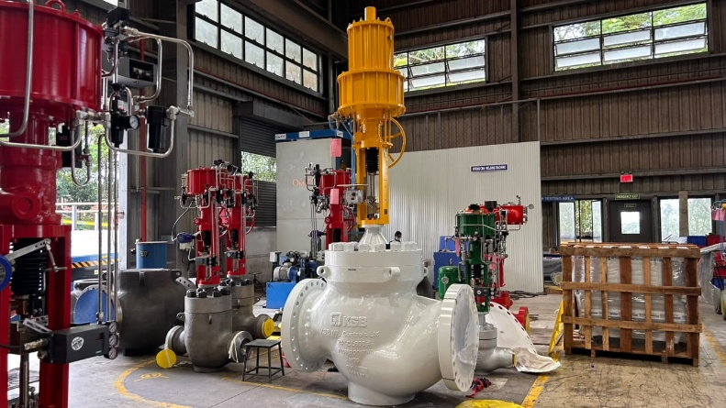 | 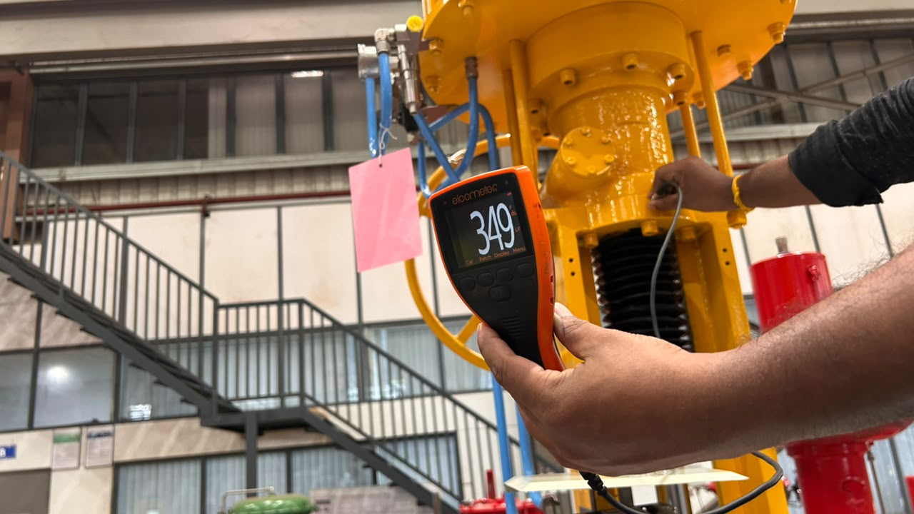
Control Valve | DFT
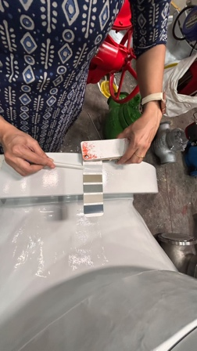 | 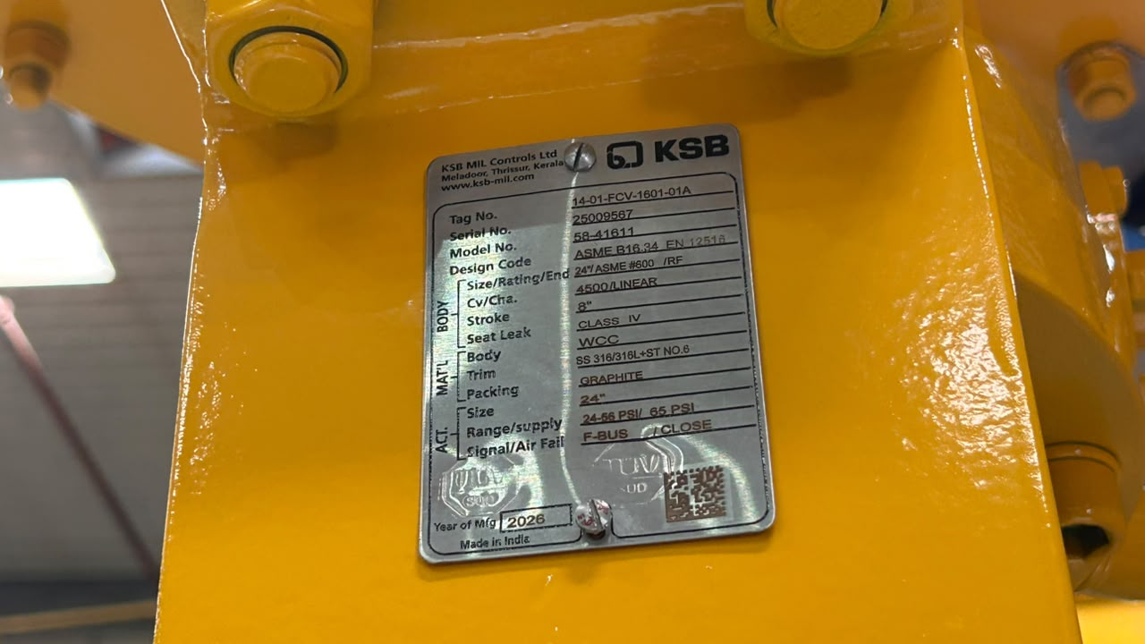
Color Match | Name Plate
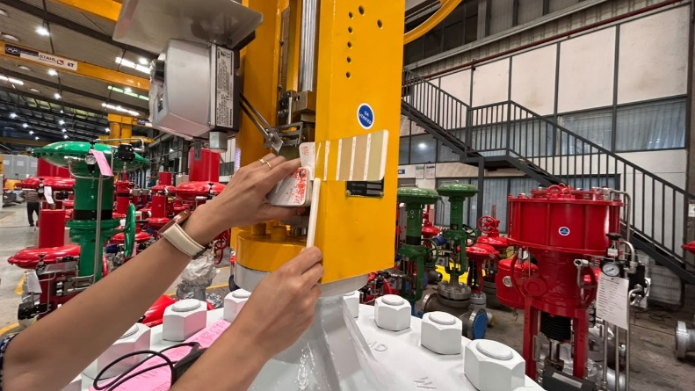 | 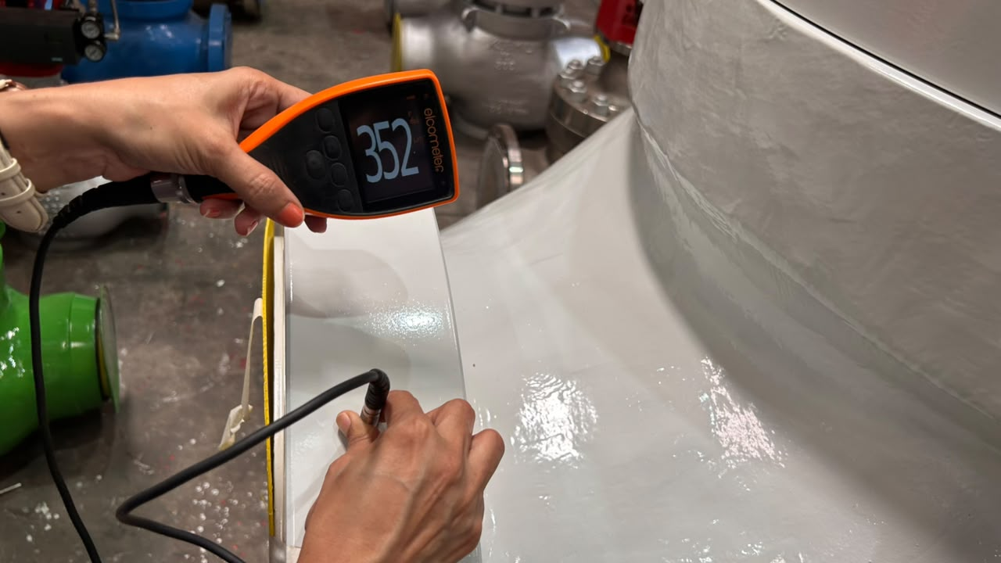
Color Match | DFT
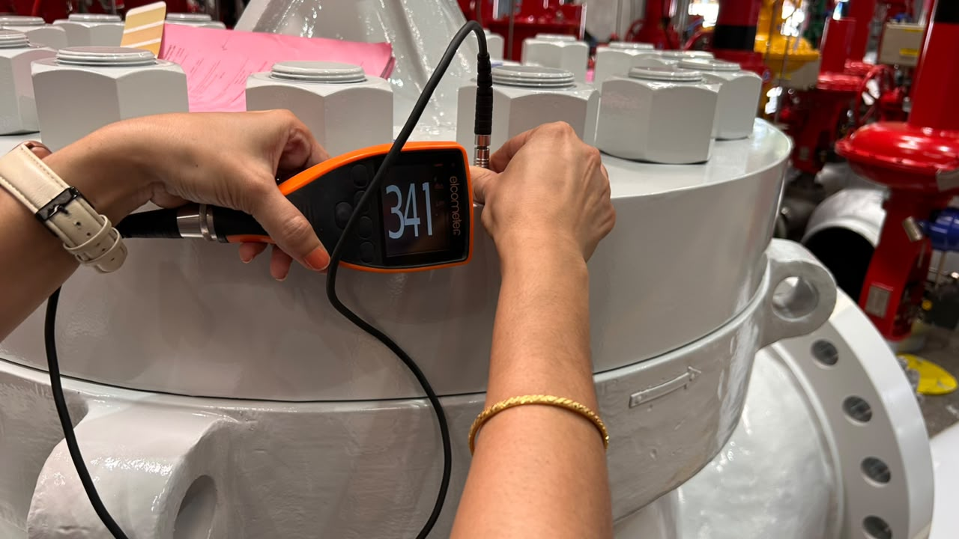 | 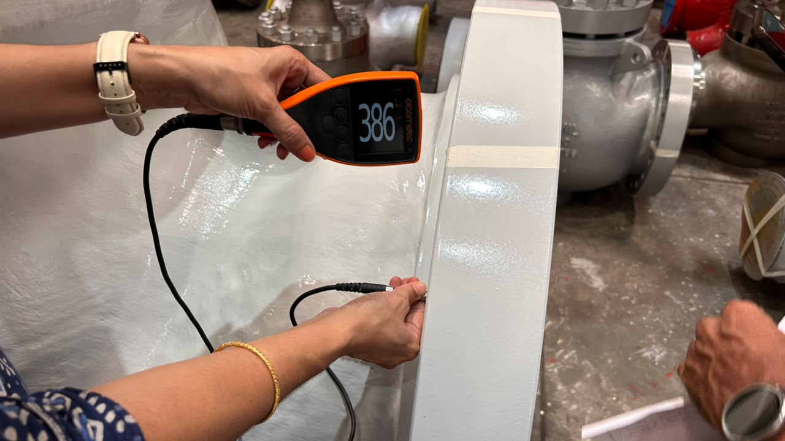
DFT | DFT
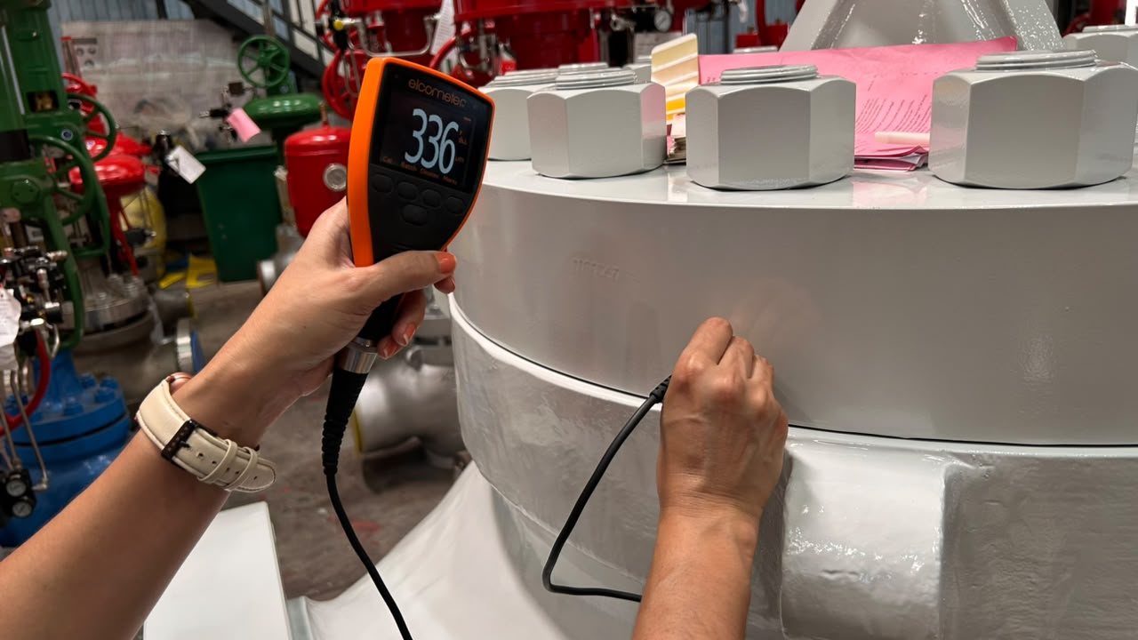 | 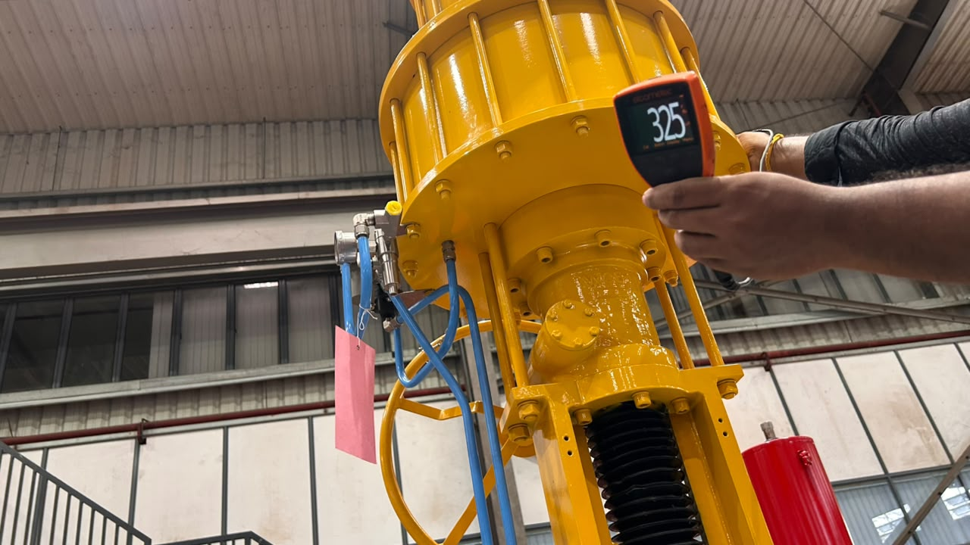
DFT | DFT
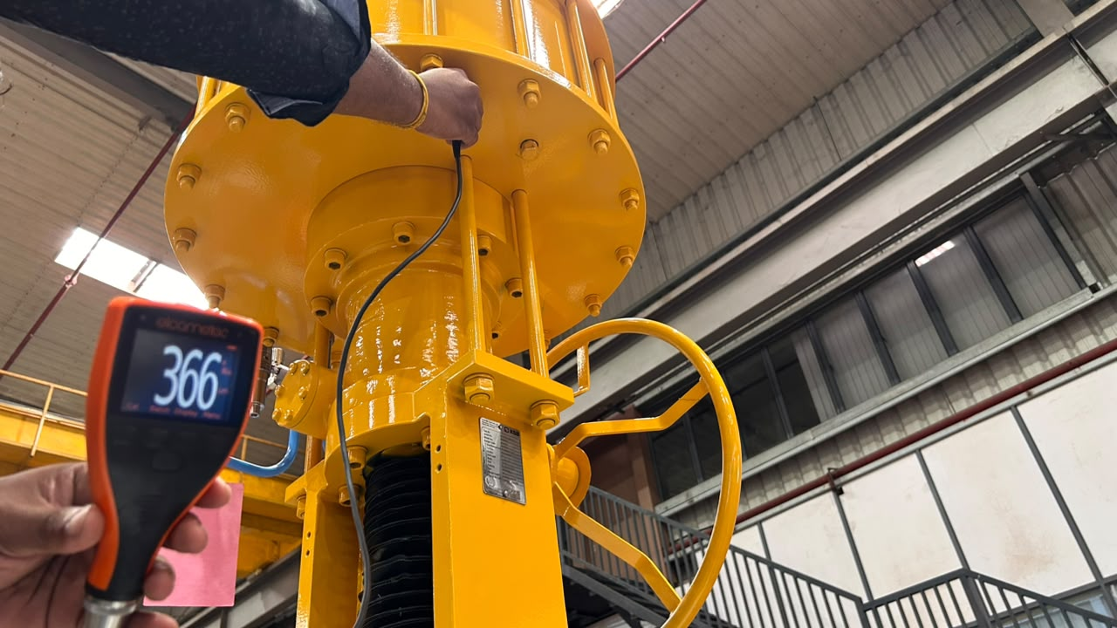 | 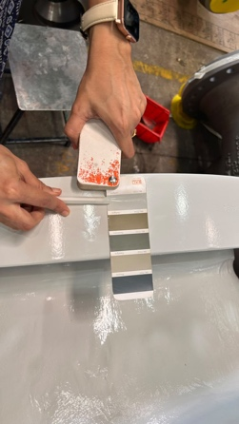
DFT | Color Match
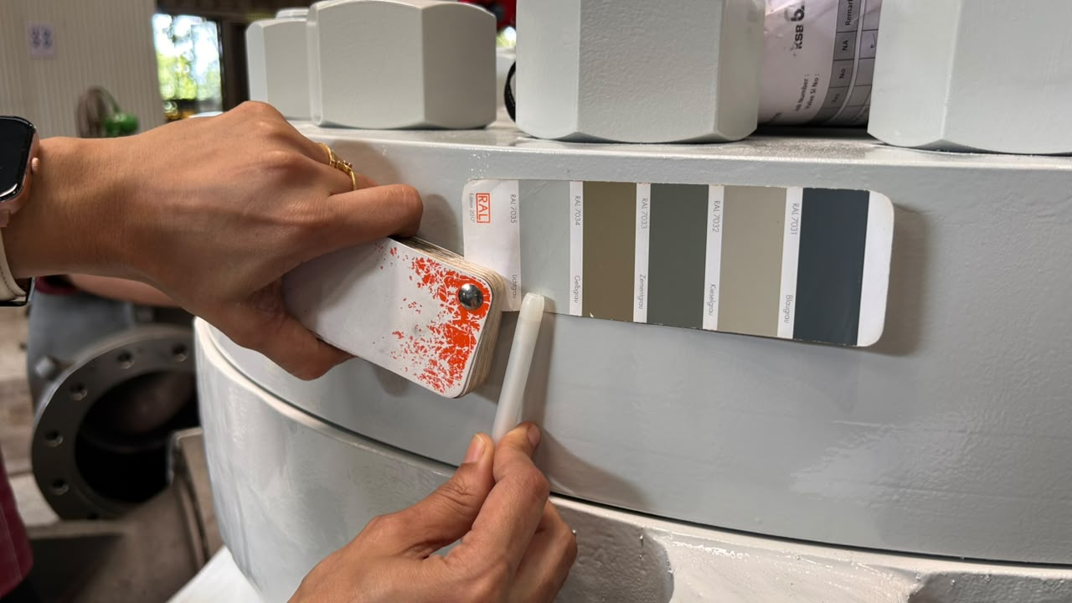 | 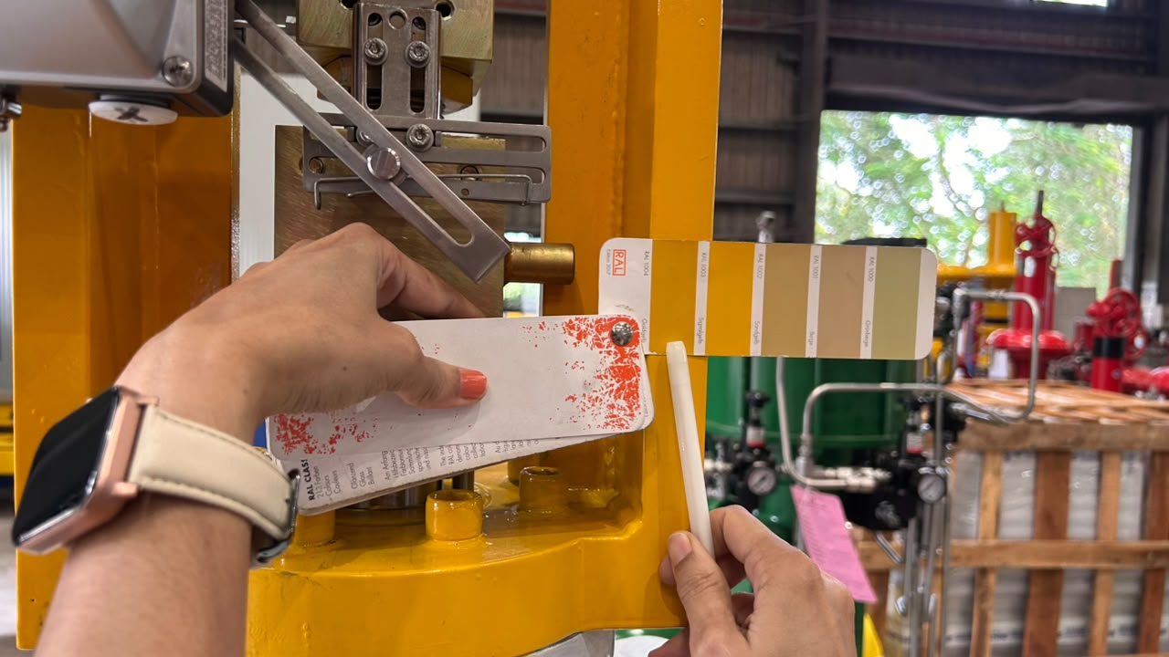
Color Match | Color Match
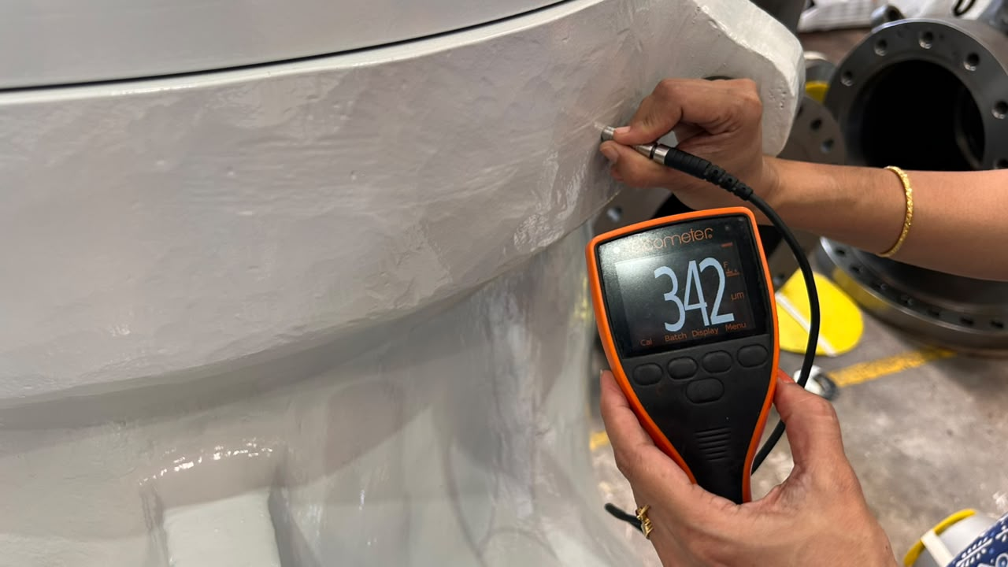 | 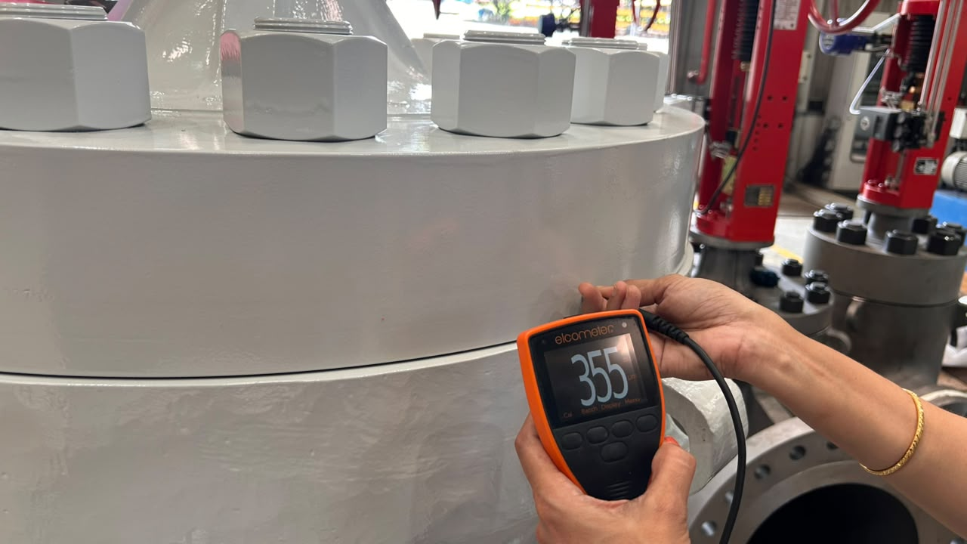
DFT | DFT
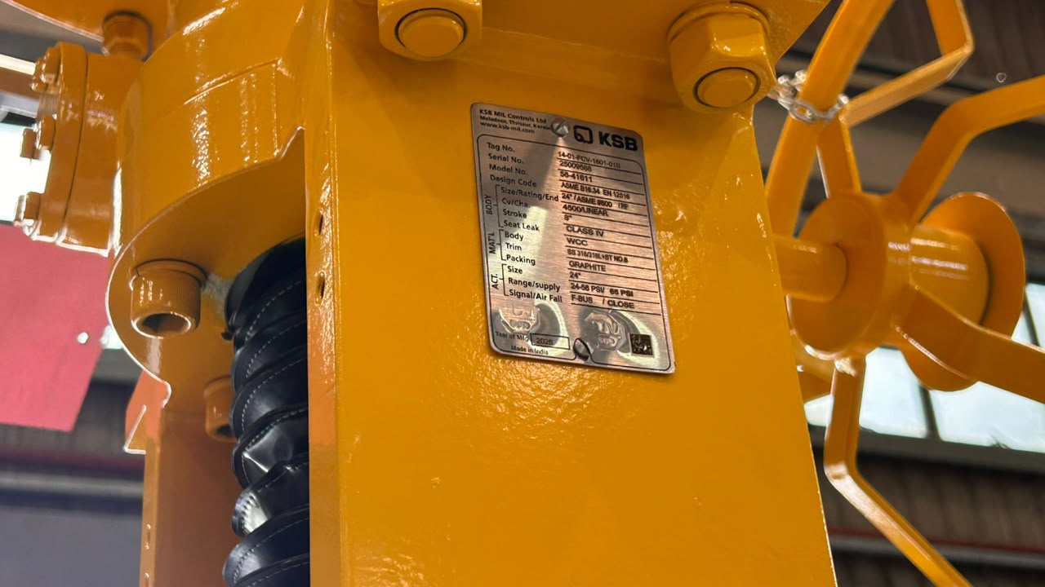 | 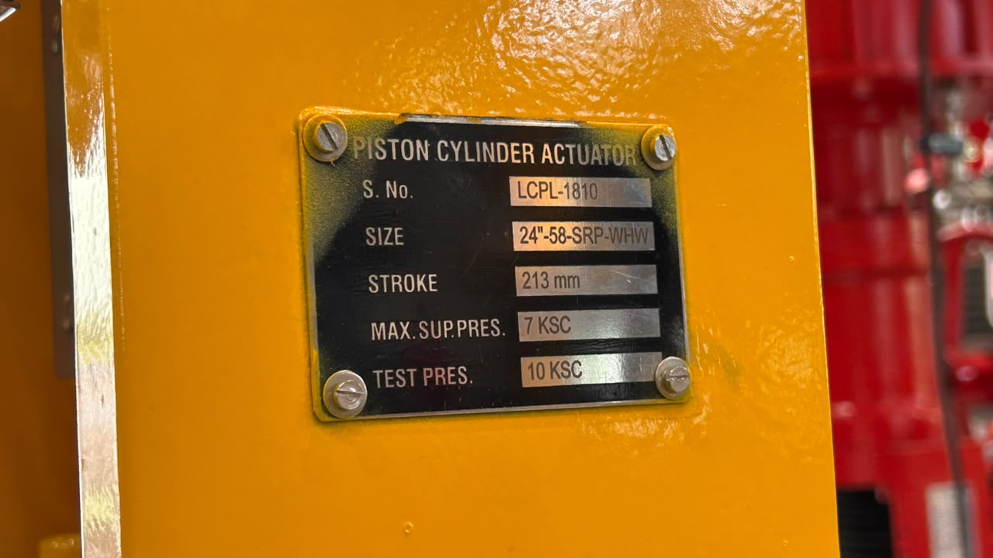
Visual Inspection | Name Plate
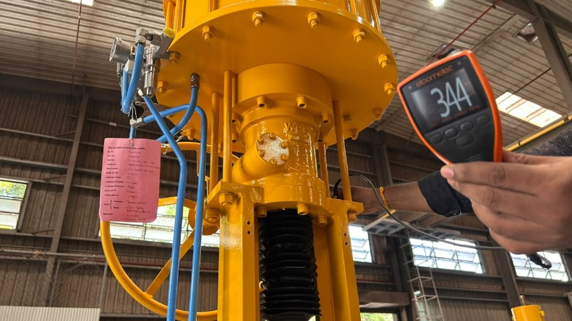 | 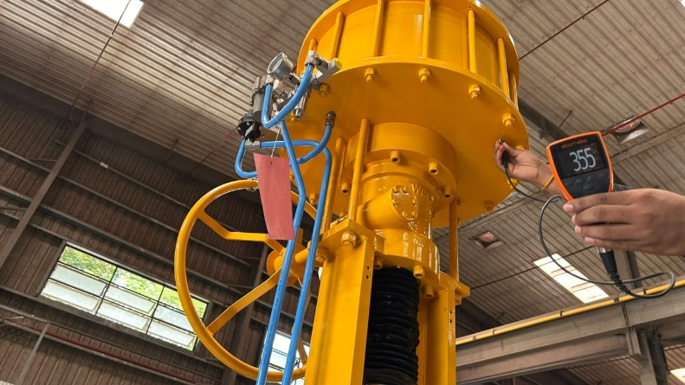
DFT | DFT
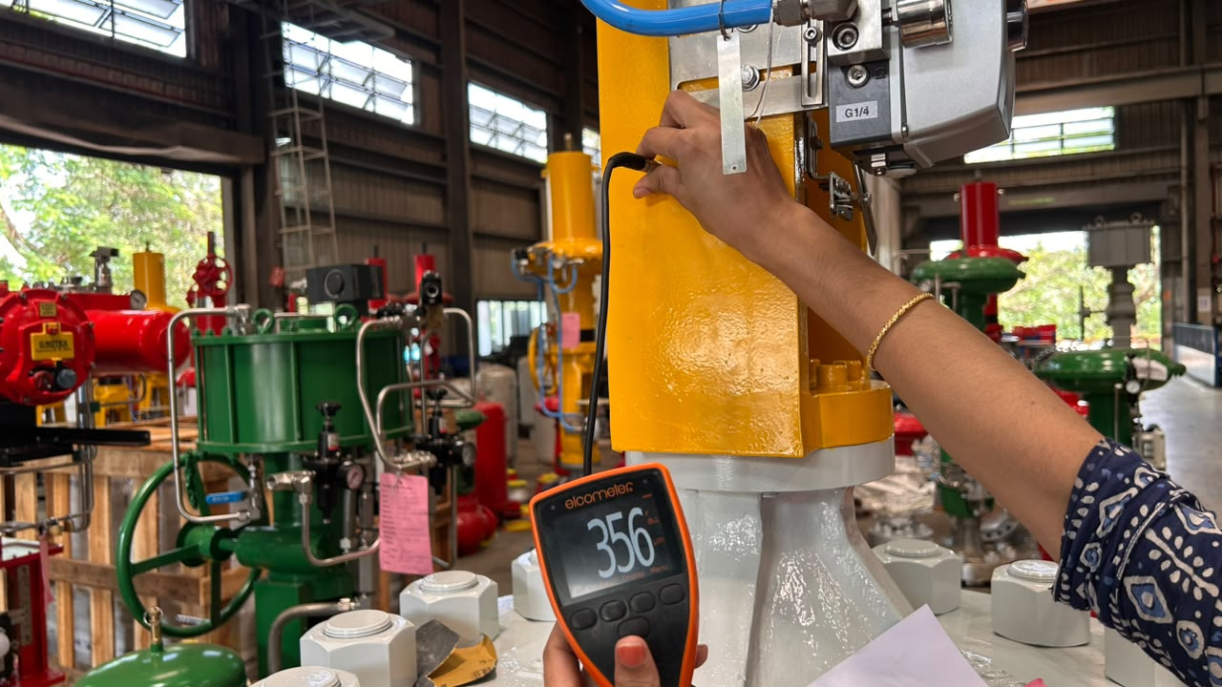 | 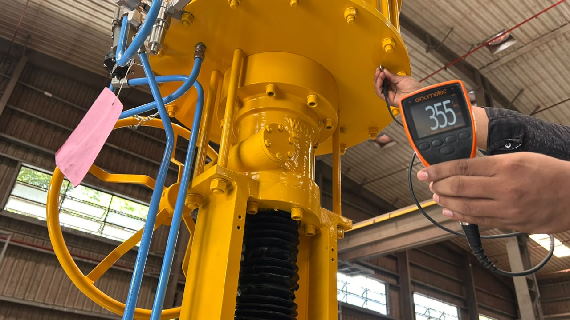
DFT | DFT
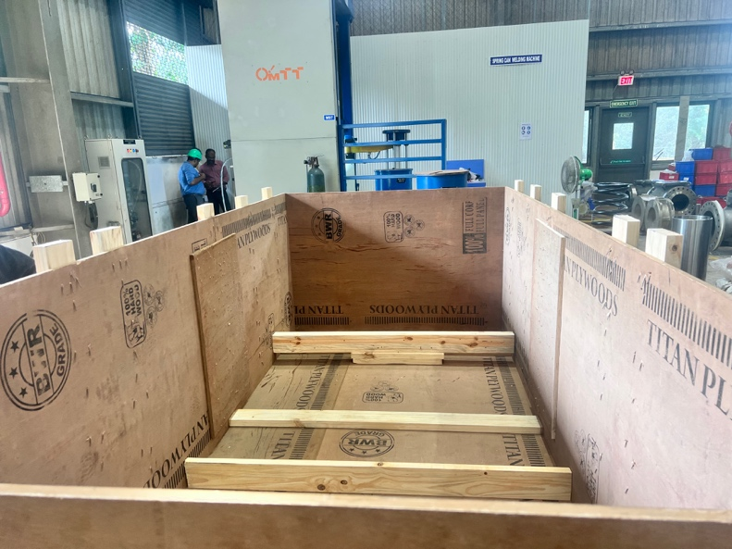 | 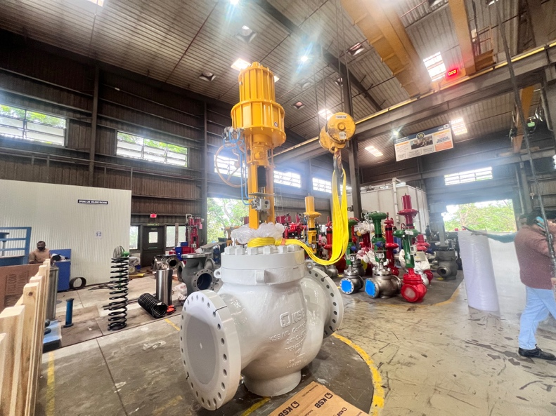
Packing | Lifting
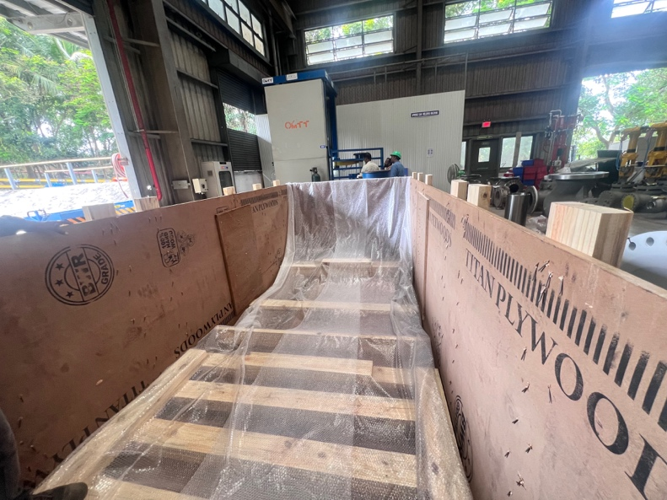 | 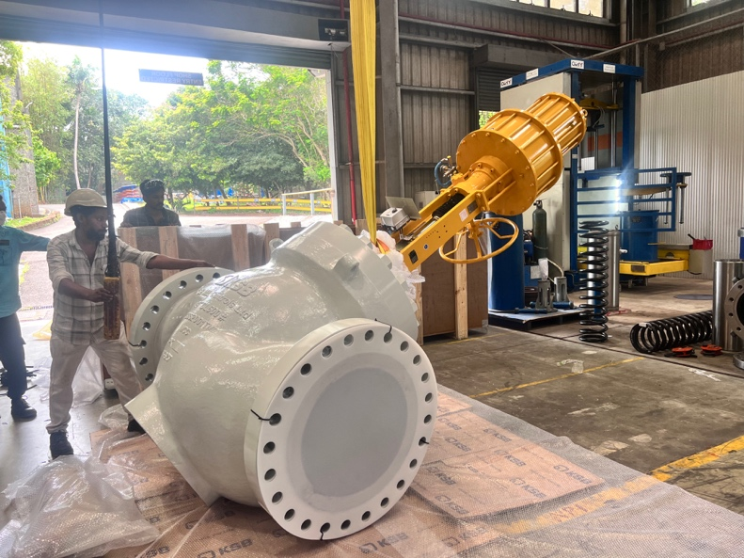
Laying Plastic | Lifting
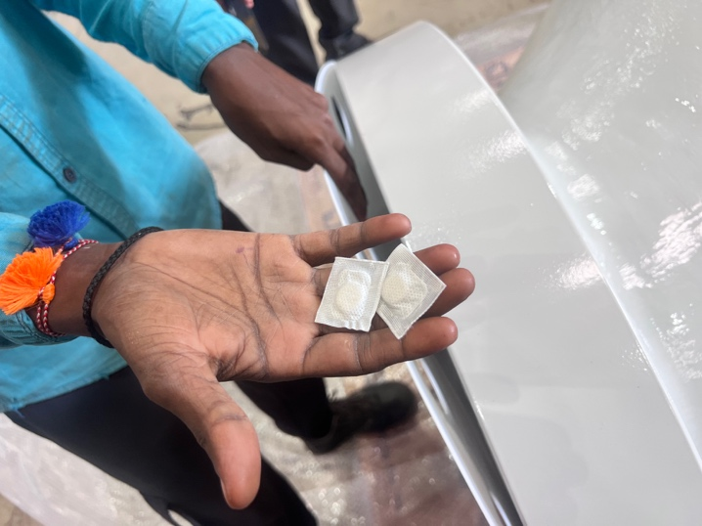 | 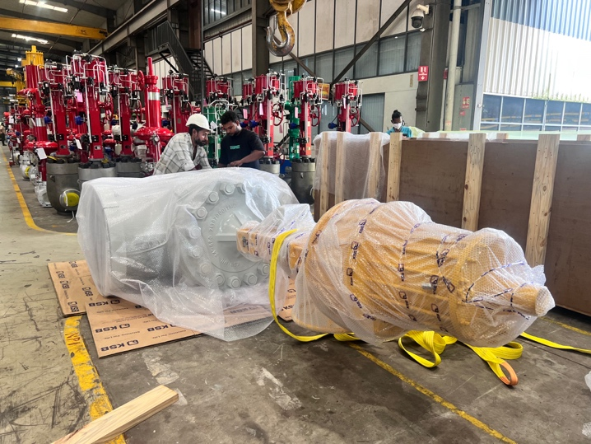
Silica Packs | Wrapping
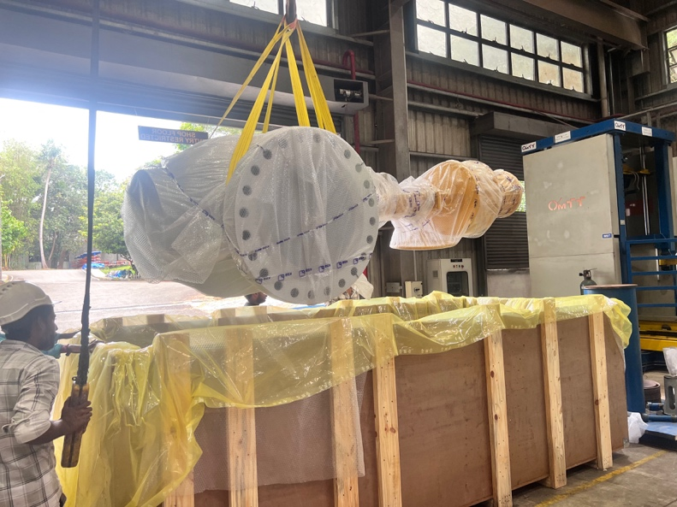 | 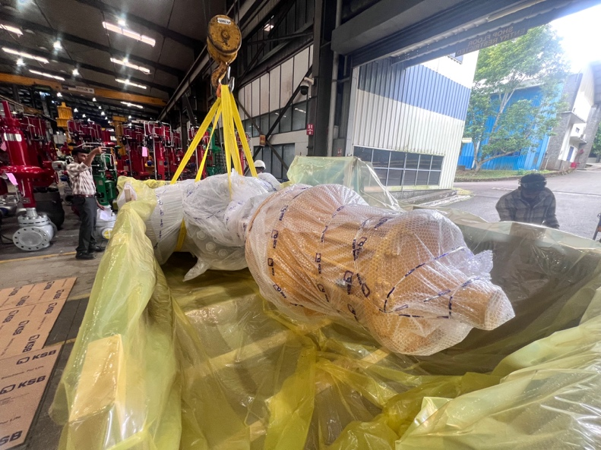
Placing | Placing
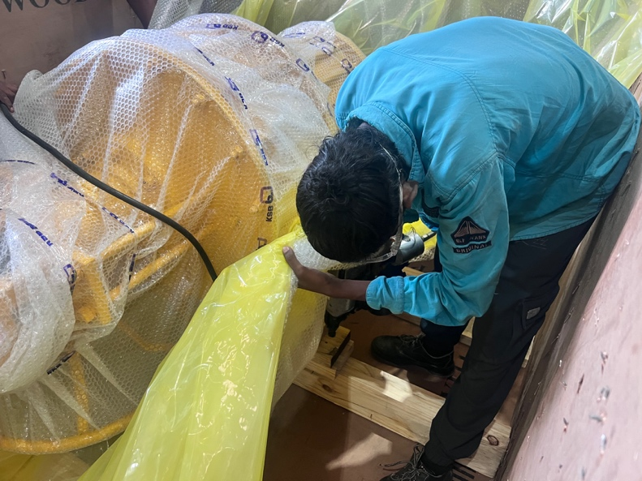 | 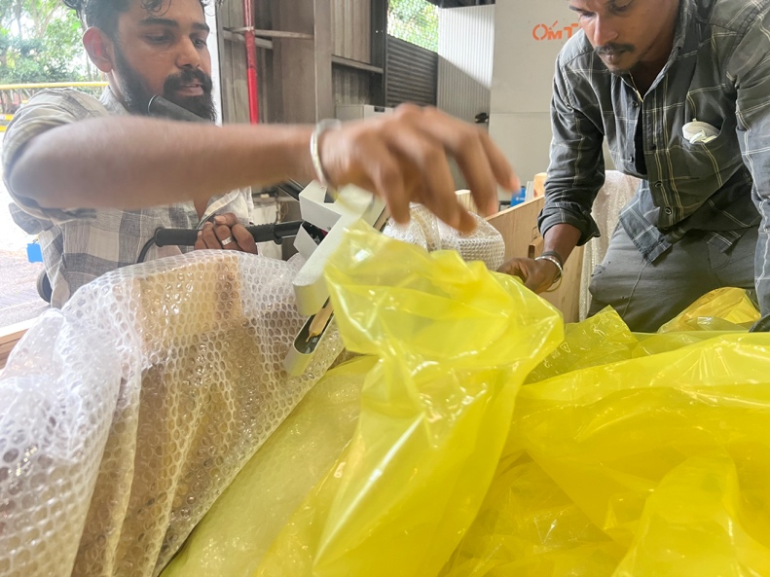
Reinforcement | Packing
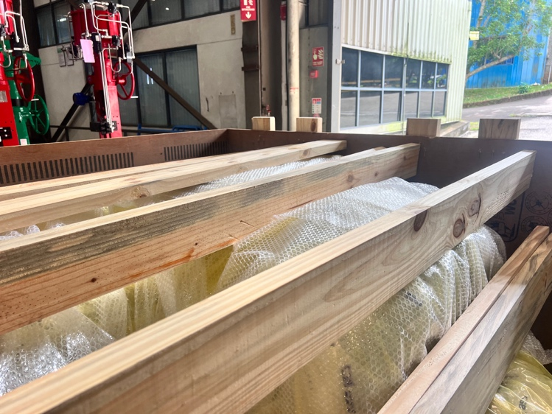 | 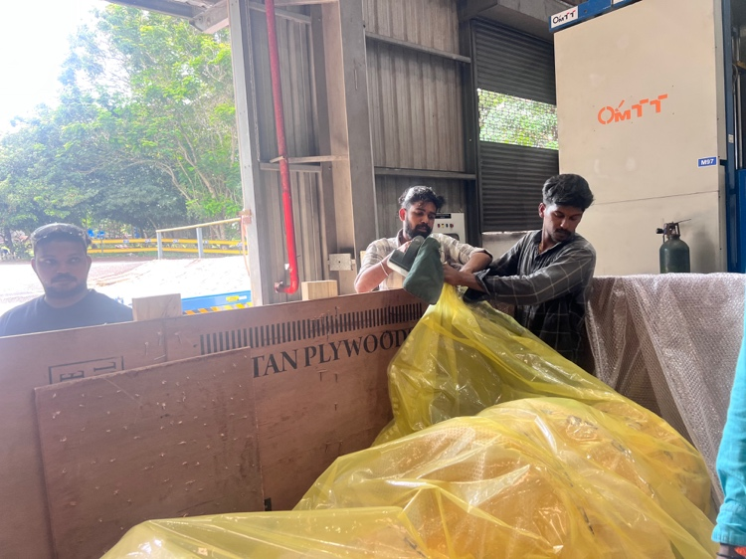
Reinforcement | Vaccum
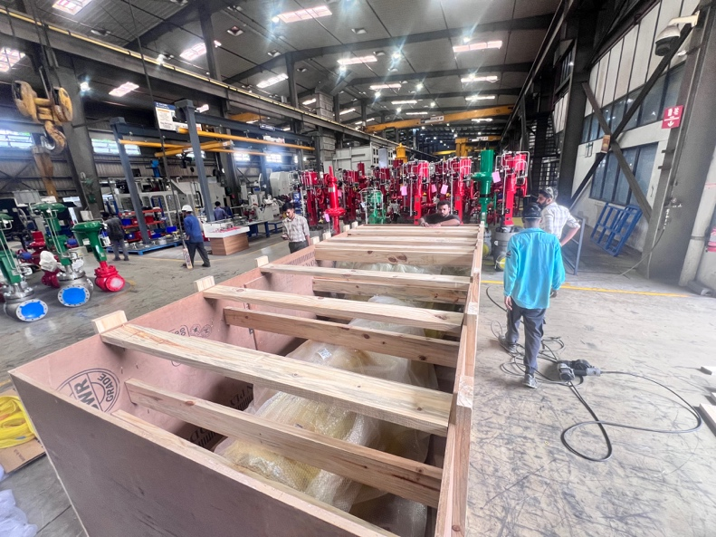 | 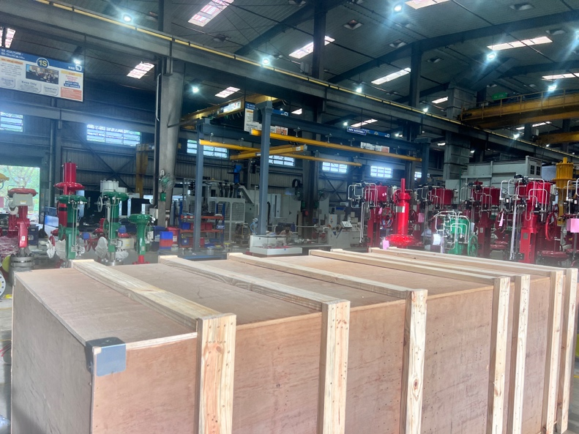
Before Clossing | After Packing
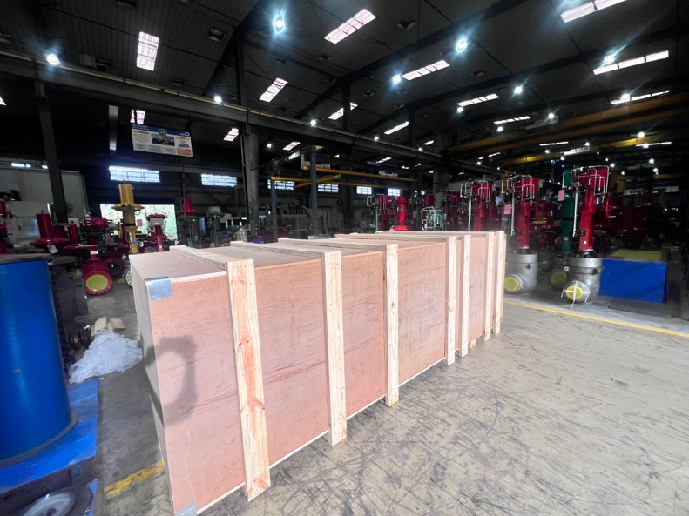
After Packing

